Guided Capstone Project Report

Big Mountain Ski Resort

Big Mountain Resort is a ski resort located in Montana that offers spectacular views of Glacier National Park and Flathead National Forest, with access to 105 trails. Every year about 350,000 people ski or snowboard at Big Mountain, which accommodates skiers and riders of all levels and abilities. Big Mountain has 11 lifts, 2 T-bars, and 1 magic carpet. Recently, the resort installed an additional chair lift to help increase the distribution of visitors across the mountain. This addition increases operating costs by $1,540,000. The resort is looking for guidance on how to price its tickets and changes to implement in order to offset the recent increase in operating costs.

We first came up with the following Problem Statement: *How can Big Mountain Resort increase its profitability by applying a new pricing strategy and/or implementing changes that can either cut costs or support higher ticket pricing - to offset the recent $1,540,000 increase in operating costs?*

Our next step was Data Wrangling, where we start cleaning up the data we were given. Initially, the data had 329 rows and 27 columns. Upon exploring the data, we found that the fastEight column is either missing its values or has the value zero, so we decide to drop it as it has no information. Our target feature is ticket prices and we have two columns for that: AdultWeekend and AdultWeekday. Upon inspection, we found that weekend prices have the least missing values compared to weekday prices so we decided to drop the AdultWeekday column. Some rows with missing values were also dropped. We ended up with a data that has 277 rows and 25 columns.

Next, we started Exploratory Data Analysis, where we looked for any pattern in the data. As shown in the figure below, there isn’t any obvious pattern between states and ticket prices. This led us to treat all states equally and work forward building a pricing model that considers all states together.

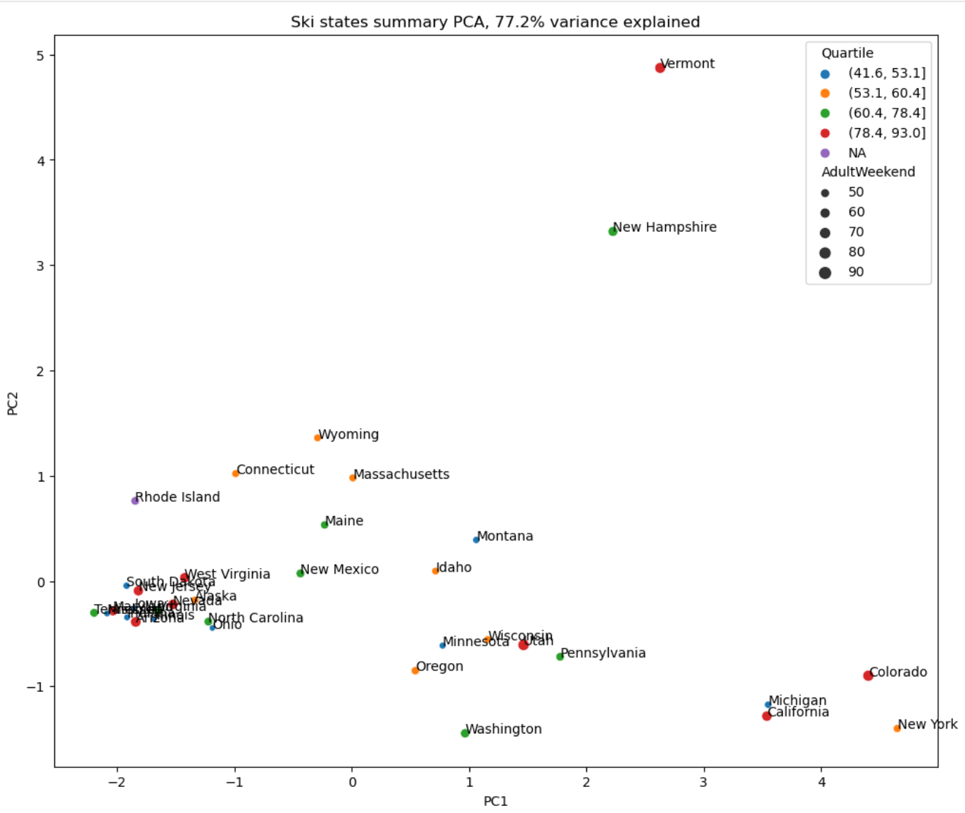

We than plotted all the features against ticket price and saw that vertical drop, fast quads, runs, and total chairs have a positive correlation with ticket price.

The next step was Pre-Processing and Training Data, where we split that data into 70/30 train/test sets. After testing different models, we decided to use Random Forest Model as it has the lowest cross-validation mean absolute error of almost $1. And as shown in the figure below, fastquads, runs, snow making, vertical drop, skiable terrain, and total chairs are the top important features to consider when modeling ticket prices.

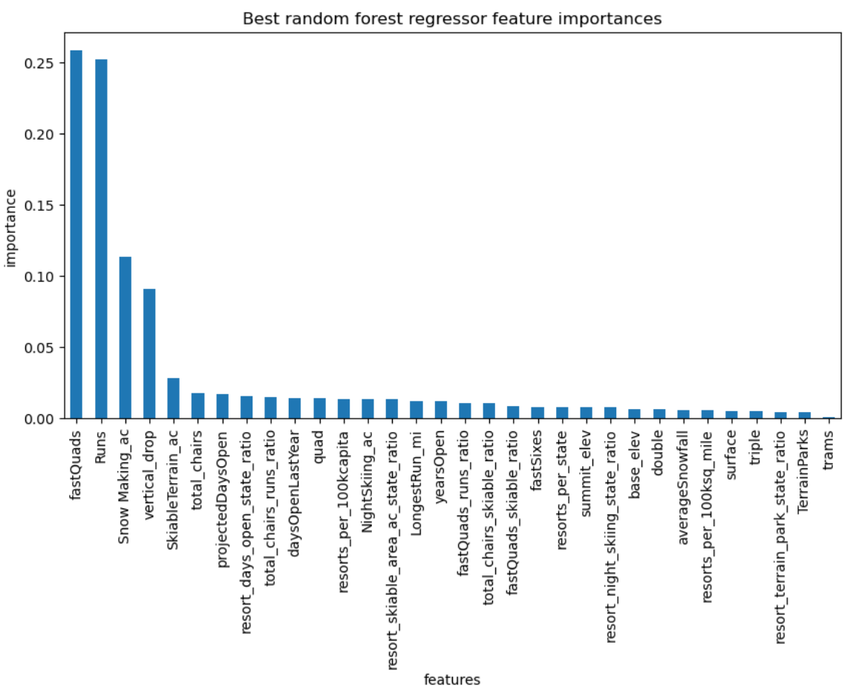

And finally, using our cleaned and processed data, we made a predictive insight.

Using the model, we colculated Big Mountain’s adult ticket price to be $95.87 but Big Mountain is currently chargeing $81.00That’s a difference of $14.87. Given that the mean absolute error is $10.39, there is still room for an increase in ticket price. Per the previous step, the features that are important inthe model are Vertical_drop, SnowMaking_ac, total_chairs, fastQuads, Runs, LongRun_mi, trams, SkiableTrarrain_ac. As shown in the figures below, while Big Mountain’s ticket price is the highest among other resorts in the State of Montana, there are a lot of resorts in other states that charge higher ticket prices. Big Mountain is also among the resorts with the largest snow-making area, the highest number of total chairs and fast quads, the longest runs, and the largest amount of skiable terrain. The resort has no trams like most resorts. And it’s doing well in vertical drop and number of runs amount other resorts, with some resorts having a greater drop and a higher number of runs. The resort can increase its ticket price because it’s doing really well in almost all facilities that people would be willing to pay more for.

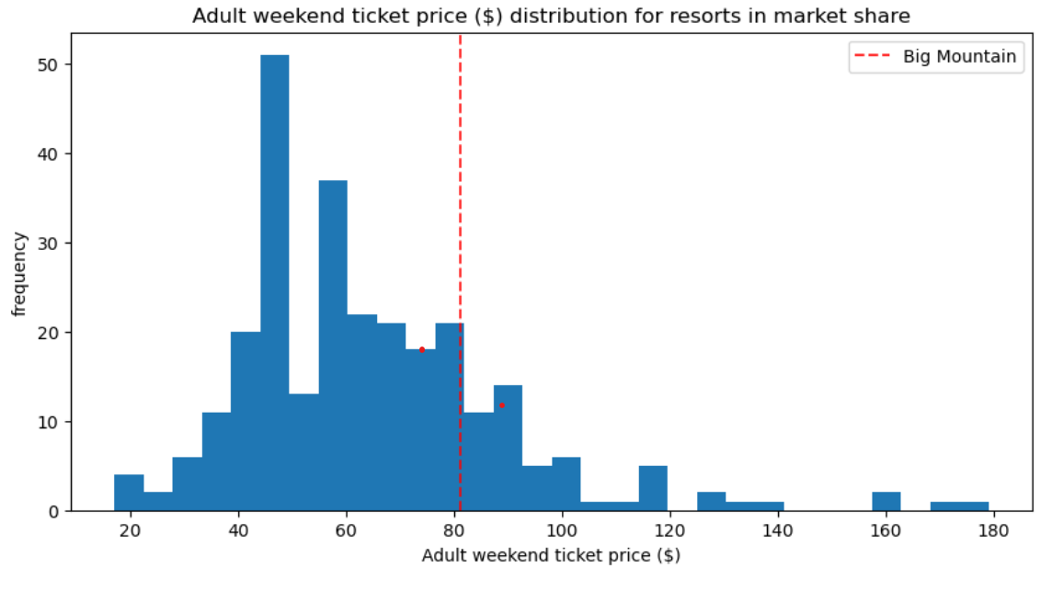

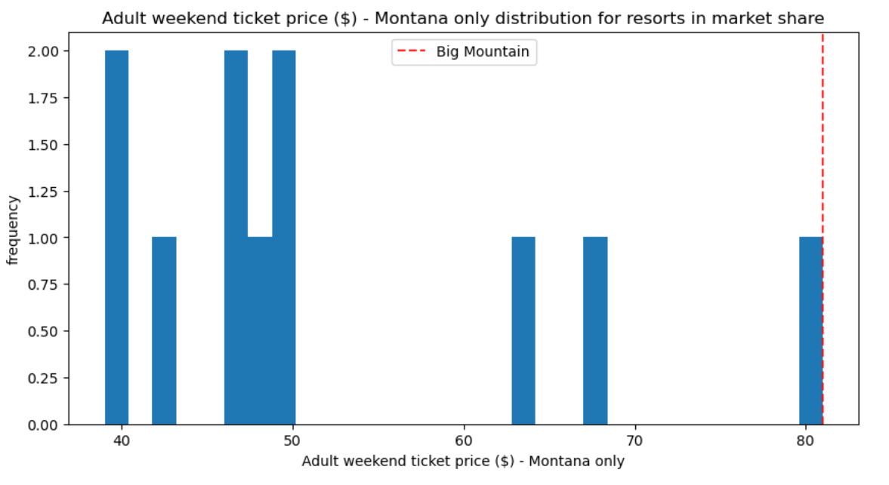

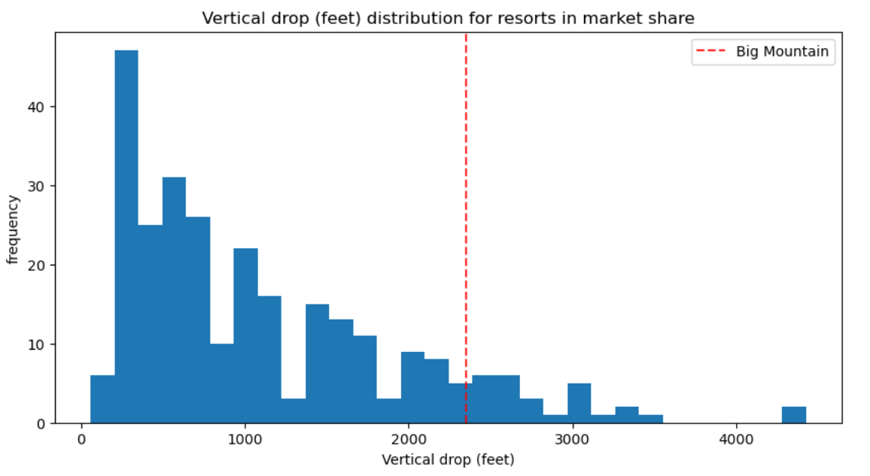

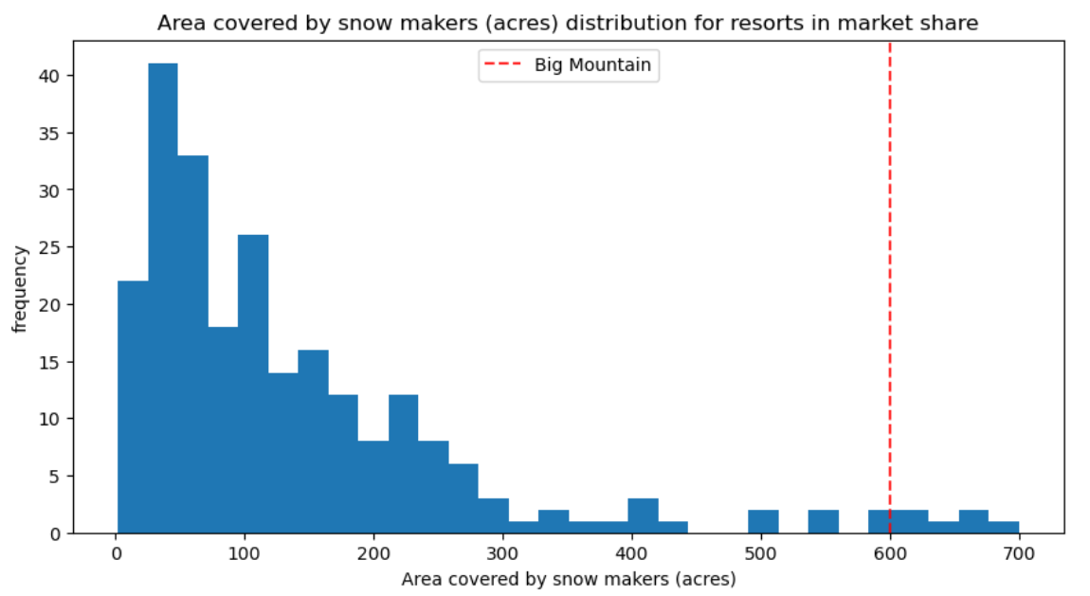

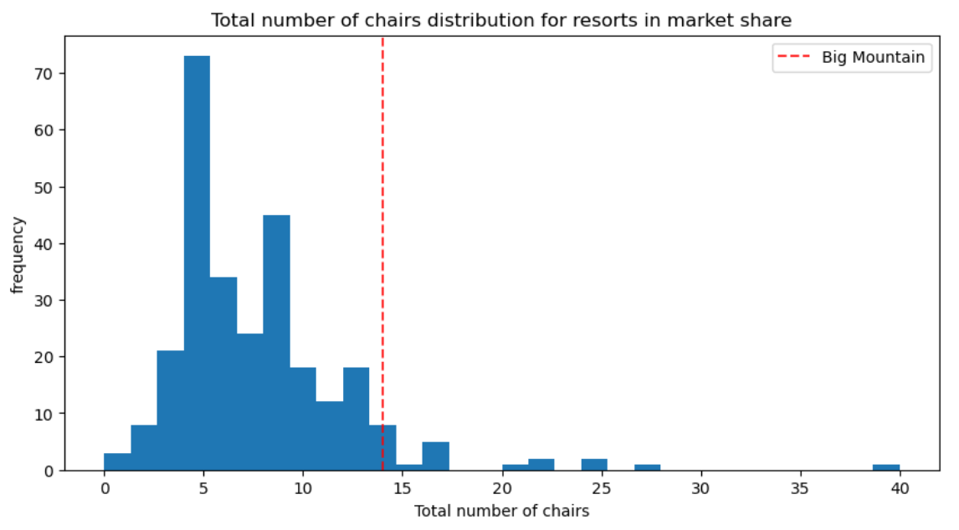

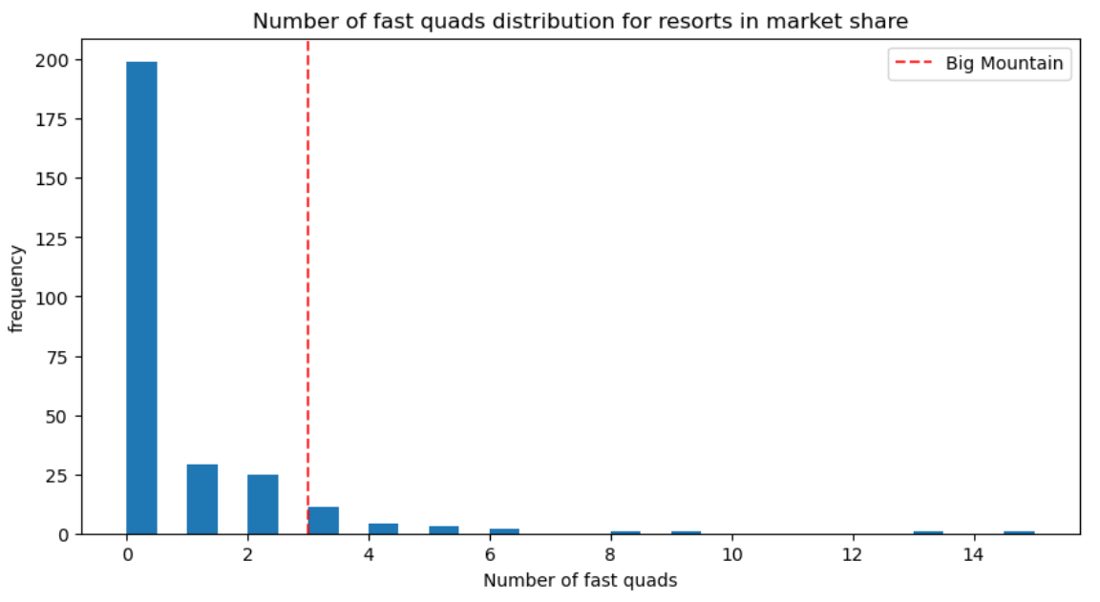

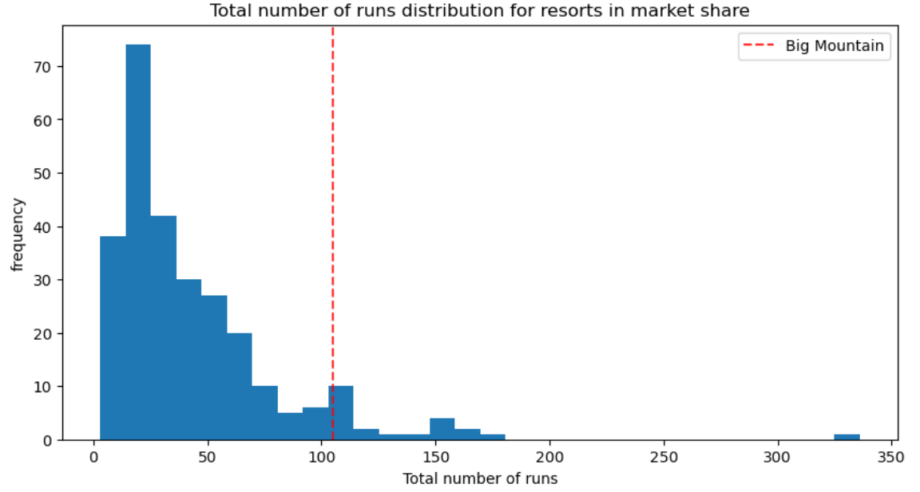

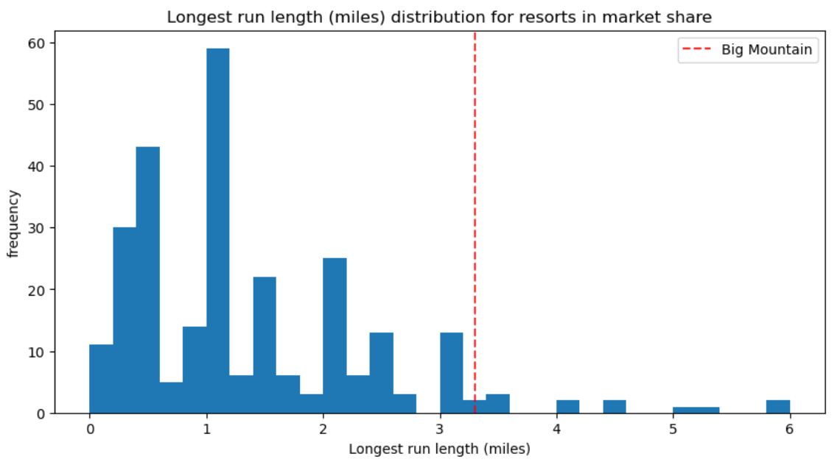

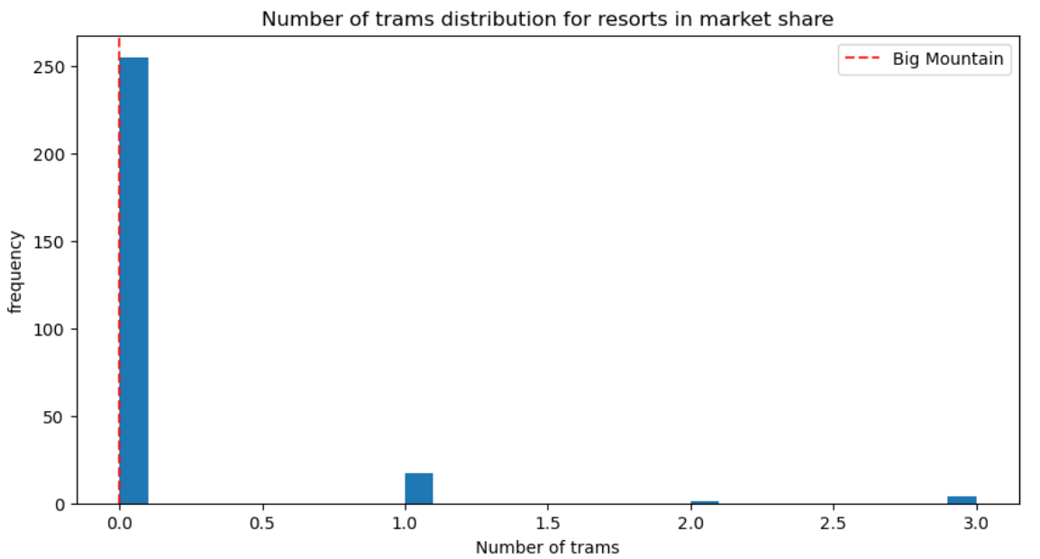

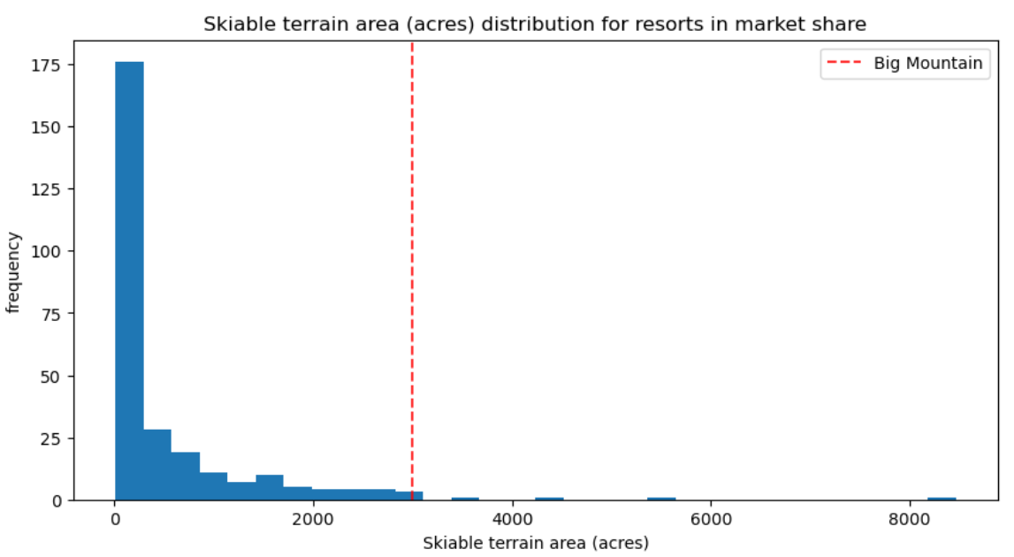

To cut costs and increase ticket prices (given that the resort has on average 350,000 visitors per season buying 5-day tickets), the resort has 4 optional scenarios. The first is to close down up to 10 of the least used runs. According to the model, closing 1 run makes no difference but closing 2 or more runs will decrease ticket price and revenue.

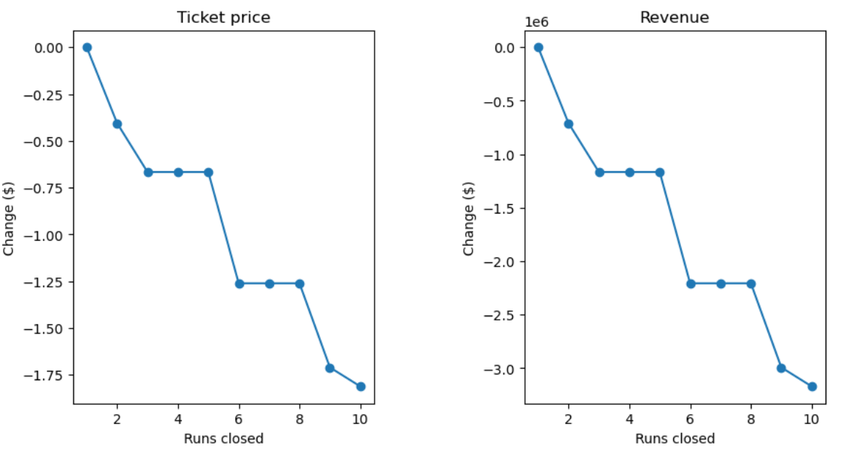

The second scenerio is to add a run, increase vertical drop by 150 feet, and install an additional chair lift. This scenario increases ticket price by $1.99 and revenue by $3,474, 638. The third is to add 2 acres of snow-making to the previous scenario. The result is the same as the previous scenario - makes no difference. And the last scenario is to increase the longest run by 0.2 miles and add 4 acres of snow-making capability. This too makes no difference to the ticket price.

Our recommendation is for Big Mountain to increase it’s ticket price to the modeled $95.87 as it is ranked fairly high on the facilities offered chart and people are willing to pay more for these facilities. Just implementing the second scenario increases the ticket price by only $1.99 which results in an increase of $3,4741,638 in revenue, which more than offsets the $1,540,000 increase in operational cost.